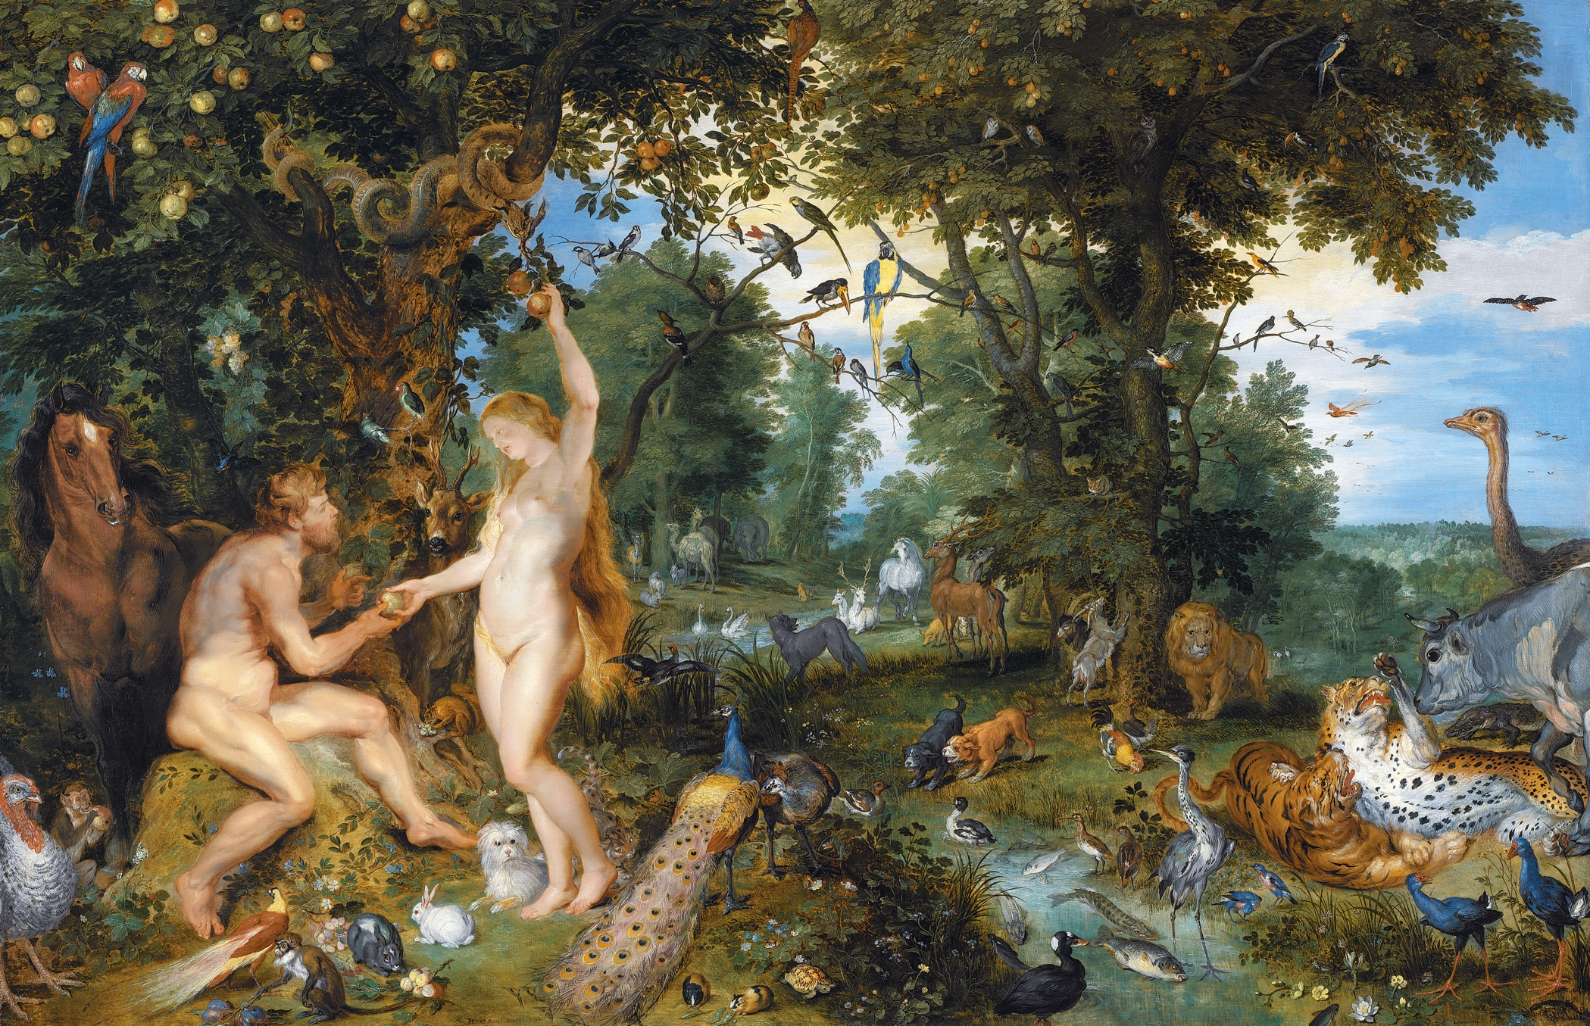
The Garden of Eden with the Fall of Man
Peter Paul Rubens, Jan Brueghel the Elder, 1615

